Smart Power Saver
Smart Street Light Project using Arduino, LDR, and IR Sensors- LDR “Light dependent resistor” and IR “Infrared Sensor” are among the most widely used electronics components. In this article we are going to use these sensors with the Arduino to build an amazing Smart Street light project. With smart street light system we can greatly reduce the energy cost and moreover smart street lights more efficiently manage electricity with lower chances of the automatic street light system overheating and risk of accidents is also minimized. Instead of turning ON the street lights for the entire night, we can design a low cost and efficient smart street light system using the Arduino, IR sensors or Ultrasonic Sensors, and some other basic electronics components.
Components:
- Light depending resistor LDR
- Arduino Uno
- 2 Channel Relay
- External Power Supply 240VAC.

What are Photoresistors?
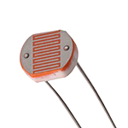

- Photoresistors, also known as light dependent resistors (LDR), are light sensitive devices most often used to indicate the presence or absence of light, or to measure the light intensity. In the dark, their resistance is very high, sometimes up to 1 MΩ, but when the LDR sensor is exposed to light, the resistance drops dramatically, even down to a few ohms, depending on the light intensity. LDRs have a sensitivity that varies with the wavelength of the light applied and are nonlinear devices. They are used in many applications, but this light sensing function is often performed by other devices such as photodiodes and phototransistors. Some countries have banned LDRs made of lead or cadmium over environmental safety concerns.

Relay:
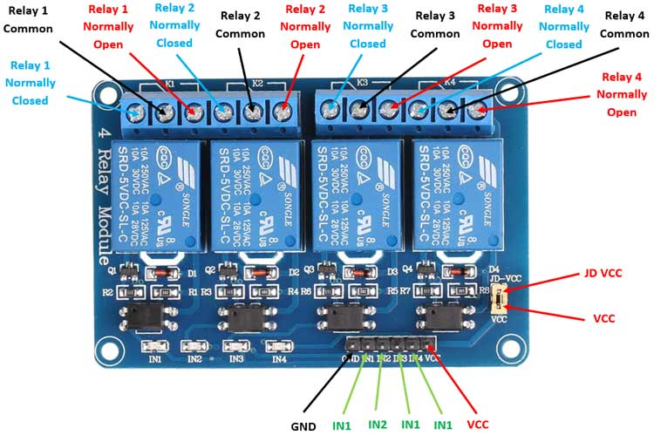
The Relay Module is a convenient board which can be used to control high voltage, high current load such as motor, solenoid valves, lamps and AC load. It is designed to interface with microcontroller such as Arduino, PIC and etc. The relays terminal (COM, NO and NC) is being brought out with screw terminal.
Circuit Diagram:
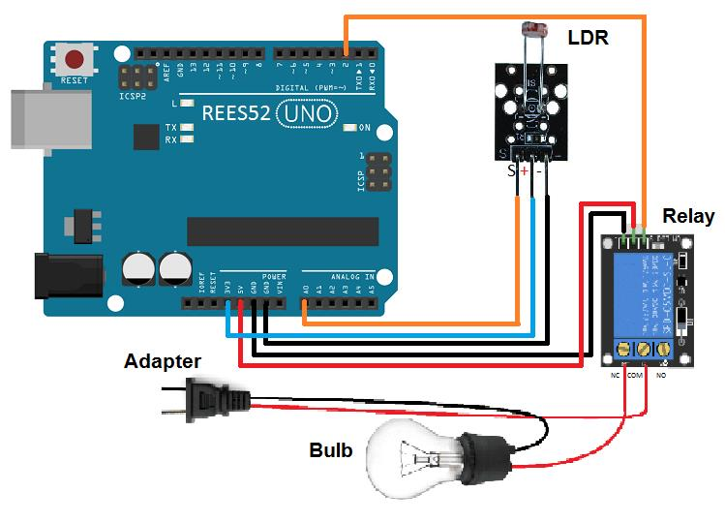
Code:
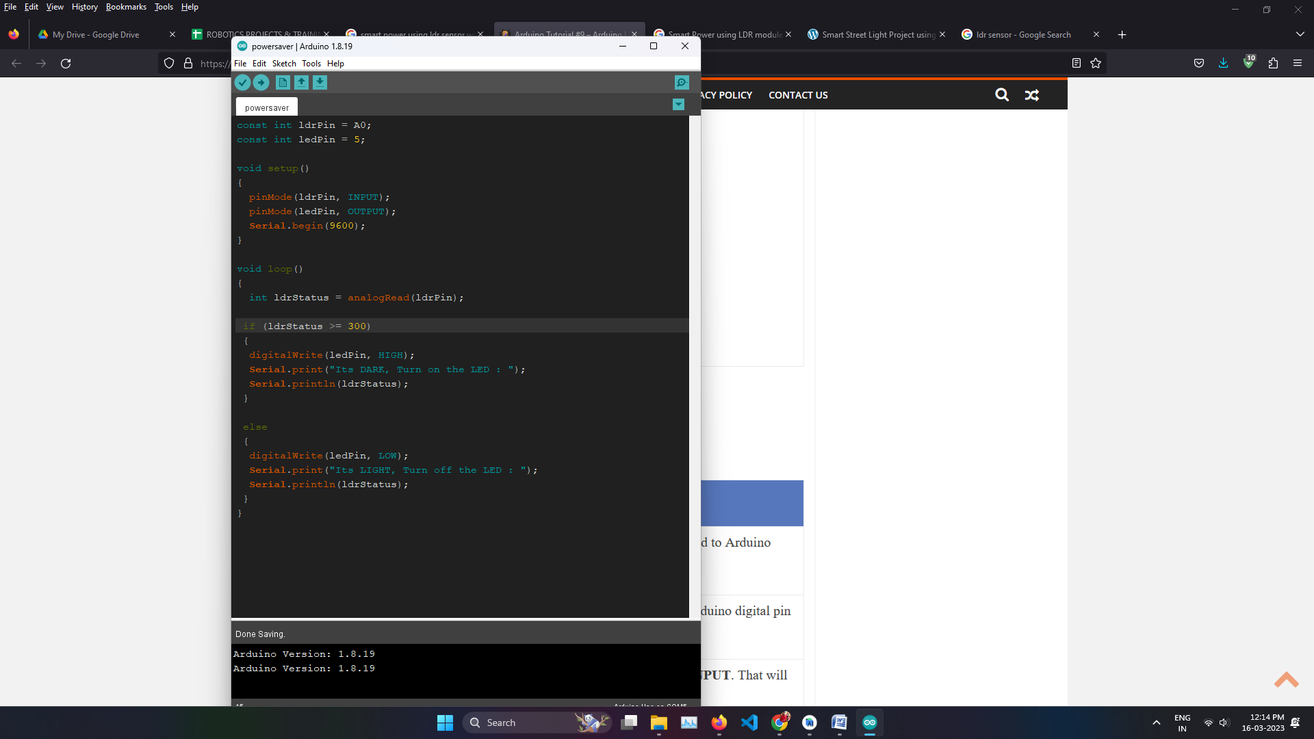

Conclusion:
A darkness detector circuit using LDR is a very simple circuit which can have many applications in the real world. This project requires very few components and is a cool system for your first electronics project. You can use this circuit as a subsystem and integrate it in your future projects.

